Calculating types of motion practice problems

Instructions: Please answer the following questions. Make sure to show all your work.
- Find the velocity in meters per second of a swimmer who swims 110 m toward the shore in 72s.

- Find the velocity in meters per second of a baseball thrown 38m from third base to first base in 1.7s.

- Calculate the displacement in meters that a cyclist would travel in 5.00h at an average velocity of 12.0 km/h to the southwest. Remember to include direction.

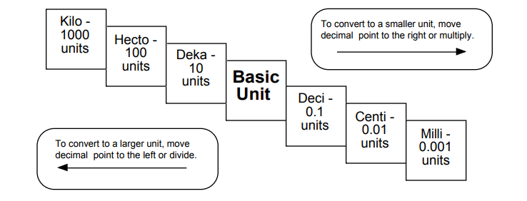
Try these conversions, using the ladder method.
