Cellular Respiration Reading and Questions – DUE 01/29/18
Processing Energy for Life
Maybe you’ve gone camping and roasted marshmallows. When you get a marshmallow too close to the fire, what happens? Poof. It ignites in a hissing blue flame. The sugar molecules in the marshmallow combine with oxygen molecules in the air to make new compounds. What are the products of this burning? Carbon dioxide, water, and energy – heat, light, and sound.
Still, a burnt marshmallow tastes all right. You pull off the burnt shell, find the warm white goo, and pop that tasty blob into your mouth. Your body breaks the marshmallow down into glucose, a sugar molecule made of carbon, hydrogen, and oxygen atoms. And what happens then? Your cells break down the glucose even further, combining the carbon and hydrogen atoms with the oxygen gas that you bring in from the air. The products of these chemical reactions? Carbon dioxide, water, and energy – the energy that your body needs to build itself and to perform life functions.
So, eating a marshmallow is like burning a marshmallow? Well – yes and no. “Yes” in the sense that the products of burning and cell metabolism are similar. “No” in the sense that the processes are different. In a fire, the reactions that break compounds and release energy are wild and explosive. In a cell, organelles and enzymes tightly control the reactions that break compounds and release energy. Without such control, the chemical reactions would release the energy too quickly, damaging the cell. In other words, you don’t see anyone bursting into flames while digesting a marshmallow. This review will trace some of the step-by-step reactions within cells that let organisms meet their energy needs.
The Importance of ATP
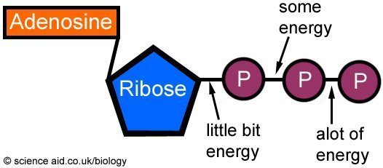
The Sun is the source of the energy that nearly all living things need to carry out their life functions. Organisms such as plants, algae, and some protists use the process of photosynthesis to harness the Sun’s energy to make high-energy sugars such as glucose. Such organisms are called autotrophs, which means that they do not consume other organisms to get their food. Animals, on the other hand, are heterotrophs – organisms that consume plants or other animals for food. After a heterotroph ingests food, its digestive system chemically breaks down the food and releases energy. Both autotrophs and heterotrophs use the process of cellular respiration to transfer much of the energy form food into adenosine triphosphate (ATP) molecules. The energy bound in ATP molecules is then sued to create all the molecules needed to support life.

At the center of an ATP molecule is a sugar called ribose. Attached to one side of the ribose is a molecule called adenine, which is a linked ring of carbon and nitrogen atoms. Attached to the other side of the ribose are three phosphate groups. ATP is not used for energy storage. Rather, ATP is used for rapid energy transfer. The chemical bond between the second and third phosphate groups stores a significant amount of energy. When this bond is broken, the reaction products are a molecule of adenosine diphosphate (ADP) and one free phosphate group, and the release of energy. The chemical energy released by the breaking of the bond is then available for use by the cell to synthesize molecules, transport substances into or out of the cell, and so on. An individual ATP molecule is broken down into ADP and phosphate, and then restored back to ATP on a very rapid basis. It is estimated that an ATP molecule in a human cell is broken down and resynthesized about 2,000 to 3,000 times per day.

- What is the advantage of living systems having a molecule such as ATP?

Cellular Respiration
Photosynthesis captures the Sun’s energy in a glucose molecule. Cellular respiration is the reverse of photosynthesis. In respiration, a cell breaks apart a glucose molecule to release energy. This energy is then used to produce ATP molecules to release energy. This energy is then used to produce ATP molecules, which the cell uses as an energy source to build organic molecules and to carry on life processes. Because this sort of respiration occurs within cells, it is called cellular respiration to distinguish it from the breathing process that most people think of as respiration. Still, there are similarities. When you breathe out, you expel both carbon dioxide and a little water vapor from your body. When a cell undergoes respiration, the waste products of the process are carbon dioxide and water. The carbon dioxide in your lung respiration is the carbon dioxide produced as a waste product by your cellular respiration.
- In which organelle does most cellular respiration take place? (Hint: Biologists call it the powerhouse of the cell.)

As you read earlier, a lot of energy is stored in the bonds between the phosphates in ADP and ATP molecules. ADP molecules have two phosphates; ATP molecules have three. All the work of respiration involves using the energy gained form breaking apart a glucose molecule to attach a third phosphate to ADP molecules. Then, as a cell needs, it breaks off this third phosphate to release the bond’s energy. Let’s follow one molecule of glucose through respiration to see how a cell extracts energy form it.
Glycolysis (a word that means “sugar-splitting) occurs in the cytoplasm. It also occurs without the presence of oxygen, so it is an anaerobic reaction. In glycolysis, enzymes in the cytoplasm break down a molecule of glucose into two molecules of pyruvic acid. Although glycolysis needs two ATP molecules to get started, it produces enough energy to make four ATP molecules. This is a net increase of two ATP molecules. Most of the energy is still trapped in the two molecules of pyruvic acid, so they need to be broken down further if more energy is to be released. These two pyruvic acid molecules then move into a mitochondrion, where the Krebs cycle begins.
The Krebs cycle occurs only in the presence of oxygen, so it is an aerobic reaction. After the two molecules of pyruvic acid move into the mitochondrion, enzymes snap one carbon atom off each of them. These carbon atoms then join up with O2 molecules to form CO2. The CO2 then moves out of the cell as a waste product of cell respiration; it is part of the gas that you expel when you exhale. The reactions in the Krebs cycle are complicated, but they do two main things: They product two ATP molecules, and they release many high-energy electrons. The two ATP molecules are used by the cell for its energy needs, The high-energy electrons become the fuel for the final stage of aerobic respiration, the electron transport chain.
The electron transport chain occurs only in the presence of oxygen, so it is an aerobic reaction. It takes place in the inner membrane of a mitochondrion. To understand what we mean by this, let’s step back a moment and look at the overall structure of a mitochondrion. A mitochondrion has an outer membrane (a covering), an inner membrane (a long series of folds), and an intermembrane space between them. The inner membrane encloses the matrix, a space that contains both protons and enzymes used in cellular respiration.
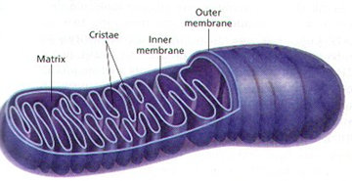
- Look at the diagram of a mitochondrion. Why are there so many folds on the inner membrane? How does this relate to a cell’s efficiency in energy production?

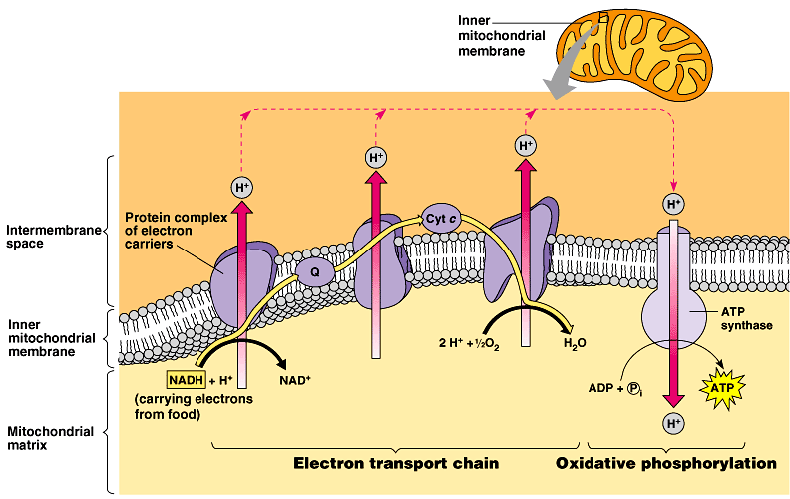
The mitochondrion’s inner membrane takes the high-energy electrons produced by the Krebs cycle and passes them along an electron transport chain. Through a series of chemical reactions, the electrons gradually “step down” in energy, releasing a little bit of energy as they go. At the end of the electron transport chain, the stepped-down electrons join with protons (H+) and oxygen molecules (O2) within the matrix to form water molecules as a waste product. This is why animals and plants must have oxygen to survive. Oxygen molecules, coupled with protons, accept and get rid of the excess electrons from respiration. Normally, the chemical reaction that forms water out of hydrogen and oxygen would produce a lot of energy – enough to kill the cell. The fact that the electrons have lost energy during the transport chain allows the formation of water to occur harmlessly within the matrix.

Let’s turn back to the energy released from the electrons as they “step down” in the electron transport chain. What is that energy used for? The mitochondrion uses it to pump protons (H+) from the matrix through the inner membrane and into the intermembrane space. This sets up a proton gradient: A high H+ concentration in the intermembrane space and low H+ concentration in the matrix. An inner membrane (a “dam”) prevents the high and low concentrations from equalizing. But all is not lost for the protons. An ATP synthase (a “turbine”) embedded in the inner membrane allows protons to pass from the intermembrane space into the matrix. Recall that the ATP synthase is shaped like a tunnel with a bulb at the end. In a mitochondrion, the bulb hangs out into the matrix and holds on to one molecule of ADP and a phosphate molecule. As a proton passes through the bulb, the ATP synthase uses the energy from the proton’s passing to bond the ADP and the phosphate into a single ATP molecule. The potential energy of the gradient is transformed into chemical energy stored in the bond that holds that last phosphate to a molecule of ATP. The ATP synthase then releases the new ATP molecule, grabs on to another ADP and phosphate molecule, and process repeats. The electron transport chain is very efficient at transforming the proton gradient into bonds of ATP. For each molecule of glucose that enters cellular respiration, the electron transport chain produces 32 molecules of ATP.
- Explain why exercising causes your body to produce carbon dioxide at a greater rate than when you are resting. Use all of the following terms at least one time in your answer: cell respiration, oxygen, carbon dioxide, glucose, ATP, and energy.

Circle the correct answer for questions 5 and 6.
- How does the electron transport chain help to accomplish cellular respiration?
  - By boosting the energy of electrons, the chain energizes various carbon molecules enough to form glucose molecules.
  - By breaking apart phosphate bonds in ATP, the chain releases enough energy to process glucose molecules during glycolysis.
  - By transporting pyruvic acid molecules form the Krebs cycle, the chain provides the raw materials for energy manufacturing.
  - By extracting energy gradually from electrons, the chain provides enough energy to change ADP into ATP.

- What is the primary purpose of cellular respiration?
  - To use sunlight to produce food molecules
  - To remove carbon dioxide from an organism
  - To release energy from food molecules
  - To bring oxygen into an organism

DUE 01/29/18

