Project: Properties of Water Comic Strip – 25pts
We read comic strips because they are funny and entertaining, but some comic strips can be used to tell a story. For this project, you will explain the different properties of water and how they relate to biology.
The comic strip below takes a science issue, global warming, and puts a comedic spin on it. This approach makes a serious subject much more light-hearted and entertaining to the general public. Your comic strip doesn’t necessarily have to be humorous, but it does have to accurately portray the properties of water.
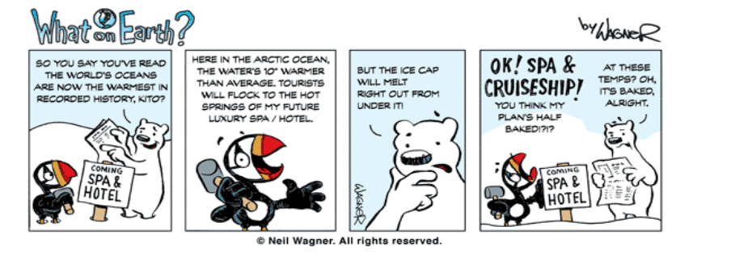
Your comic strip must:
- Be composed of at least 6 frames
- Include colored illustrations (hand drawn) in each frame depicting the properties of water.
- Feature short captions underneath it (in complete sentences) that provide details about what is occurring within each frame. Note: You may type the captions
- Include the following terms in the frame captions (terms should be underlined):
  - Solvent
  - Cohesion
  - Adhesion
  - Surface Tension
  - High heat capacity
  - Solid, liquid, gas
- Include dialogue bubbles for the characters in your comic strip.
- Be carefully cut from the original worksheet and affixed (frames in order) to an appropriate backing (poster paper, construction paper, etc.)

